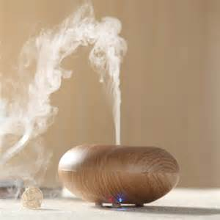
Fun with Diffuser Blends
Focus Blend Nighty Night Blend
2 drops Rosemary 3 drops Serenity
2 drops Frankincense 2 drops Wild Orange
2 drops peppermint

Bliss Blend Stress-fighting Blend
3 drops Citrus Bliss 2 drops Bergamot
2 drops Rosemary 2 drops Frankincense
2 drops Elevation

Autumn Blend Immune-boosting Blend
2 drops Arborvitae 3 drops OnGuard
2 drops Cardamom 2 drops lemon
2 drops Lemon 1 drop Oregano

Gratitude Blend Happiness Blend
1 drop Ginger 2 drops Frankincense
1 drop Cinnamon 2 drops Peppermint
2 drops Coriander 2 drops Lime
2 drops Wild Orange 1 drop Clove

Stink Away Blend Liquid Sunshine
3 drops Purify 3 drops Wild Orange
2 drops Lemon 3 drops Grapefruit
2 drops Lemon
2 drops ‪Bergamot‬
DoTerra Blends
OnGuard Terra Shield Elevation
Balance Citrus Bliss Breathe
Console DigestZen Serenity
Peace Forgive Motivate
Cheer Passion Purify

www.feedingyourlife.com

